TeeBI v1.0 (document version 6)
Starting Guide (for Delphi and C++)
www.steema.com
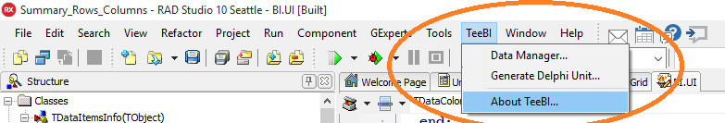

What is TeeBI ?
TeeBI is a performance-oriented API (component library) to enable data gathering, processing and optionally interacting with machine-learning algorithms.
Data can be created manually by code, or it can be automatically imported from many different sources and formats, like databases, or files as csv, json, xml, Excel, etc both by code of using editor dialogs.
Data can be optionally persisted to native binary files that provide ultra-fast access, as each column or field is directly stored from a simple array in a single operation. Millions of rows take few instants to load, sort, aggregate or traverse.
Basic summary features like filtering, sorting, expressions, aggregations and multiple group-by consolidations can be done using simple classes and/or visual editor dialogs. No sql required.
Integrations with the “R” language and Python’s frameworks like Scikit-learn provide an easy way to use TeeBI data with statistical and machine-learning algorithms from a common Delphi-style set of classes and components, without requiring to write R or Python scripts.
Data visualization is delivered by a TBIGrid and TBIChart controls, both for VCL and Firemonkey, that can automatically display data and summary outputs with no coding required.
A TBIDataset component links to any data object using a simple Data property. TBIDataset can be used like another TDataset.
Plugin classes are provided to choose your preferred 3rd party Grid control (Jvcl, TMS, SMDB, Woll2Woll, etc) and data import components (OmniXML, SuperObject, UniDAC, etc) instead of the default Delphi included ones.

Introduction

TeeBI can be used in two different modes:
- Low level (just runtime support, no design-time)
- High level (design-time)

The next section (“Low level”) is an overview of the library base classes.
If you want to skip programming, jump directly to High Level section.

Low level
In this mode, its not necessary to compile and install any package. Just add TeeBI source code folders to your project (Project->Options->Delphi directories->Search Path), or to global environment Tools->Options, and start using TeeBI units.
The paths of TeeBI source code are:
Common base sources: ..TeeBee\Sources
VCL specific sources: ..TeeBee\Sources\VCL
Firemonkey specific: ..TeeBee\Sources\FMX
Optionally, folder containing algorithm-related sources:
..TeeBee\Algorithms

Simple demo:
The following low-level features are included in a test project located inside the folder that contains this document:
Docs\Starting Guide\Samples\BI_Tests.dpr
Before opening this sample project, packages should be recompiled and installed using the TeeBIRecompile.exe tool that comes with TeeBI source code.
The TeeBIRecompile.exe tool adds a registry key to declare a data “Store” (see more about Stores later) named “BISamples”, pointing to the folder “Sample Data” that comes with TeeBI installation.
The “Sample Data” folder contains a collection of popular datasets in different formats, already imported and persisted into native binary TeeBI data files.
These datasets are used by TeeBI demos and examples for many different purposes.

Class structure:
The main class in TeeBI is called: “TDataItem”
TDataItem is simply a container for data, and can be configured in three different ways:
- As a “column” of simple data, like numbers, text, dates, etc (equivalent to a dataset “field”).
- As a “grid” that has one or more “columns” (equivalent to a dataset “table”).
- As a “list” of TDataItem (equivalent to a “database” that has a group of “tables”).
The interesting thing here is that any “column” can also contain child columns, being each one of any of the above kinds. This makes possible to configure simple structures like plain tables, and also “unstructured” or hierarchical, like for example data coming from JSON, XML or NoSQL contents.

In some way, a TDataItem class resembles Python lists or Numpy ndarrays, or R DataFrames.

First sample:
Creating a column (field):
uses BI.Data; // <-- main unit
var Numbers : TDataItem; // <-- instance
Numbers:= TDataItem.Create;
Numbers.Name:= ’Quantity’;
Numbers.Kind:= TDataKind.dkInt32; // <-- type of data
Numbers.Resize(1000); // <-- number of elements (this simply resizes an internal array)

Filling data:
Data inside TDataItem lives in simple arrays, one array for each different data kind.
var t : Integer;
for t:= 0 to Numbers.Count-1 do
Numbers.Int32Data[t] := Round(123*Random);
Note: It is currently not possible to use language “generics” to reduce all data kinds to a single generic array.
This is the reason of having several XXXData array fields instead of just one Data array of generic type “T”.

Creating a “grid” (table):
var Customers : TDataItem;
Customers:= TDataItem.Create(True); // <-- True means it is a table
Customers.Name:= ‘Customers’;
// Add columns
Customers.Items.Add( ‘CustomerID’, TDataKind.dkInt32 );
Customers.Items.Add( ‘Name’, TDataKind.dkText );
Customers.Items.Add( ‘BirthDate’, TDataKind.dkDateTime );
Customers.Items.Add( ‘City’, TDataKind.dkText );
Customers.Items.Add( ‘Salary’, TDataKind.Single );
// Fill one row
Customers.Resize(1);
// Row zero values:
Customers[‘CustomerID’].Int32Data[0] := 1;
Customers[‘Name’].TextData[0] := ‘Acme Inc’;
Customers[‘BirthDate’].DateTimeData[0] :=EncodeDate(1967,4,13);
Customers[‘City’].TextData[0] :=’Barcelona’;
Customers[‘Salary’].SingleData[0] := 123.45;
Creating a “list” (group of data):
var Demo : TDataItem;
Demo:= TDataItem.Create;
Demo.Items.Add(Numbers);
Demo.Items.Add(Customers);

Accessing Items (columns)
Using the default property of data, chaining consecutive names:
var D : TDataItem;
D:= Demo[‘Customers’] [‘City’];
This is equivalent to:
D:= Customers[‘City’];
The above syntax will raise an exception if a given name cannot be found in the items array.
If you wish to check the existance of a name without raising the exception, use the Find method instead:
if Demo[‘Customers’].Items.Find( ‘City’ ) then
...

Persisting data:
The BI.Persist.pas unit contains classes to save and load TDataItem instances to any TStream, or to a disk file.
Data is divided in two sections:
- Structure (data name, data kind, children data, basic statistics etc)
- Data array contents (the real data in the arrays) and data “maps” (indexes)

These two sections can be saved to a single stream:
uses BI.Persist;
var M : TMemoryStream;
M:= TMemoryStream.Create;
TDataItemPersistence.Save( Demo, M );
...and then reloaded it later:
Demo.Free; // <-- forget existing data and release memory
M.Position:= 0;
Demo:= TDataItemPersistence.Load( M );
// Get variables again :
Customers:= Demo[‘Customers’];
Numbers:= Demo[‘Numbers’];

In a later part of this document (when describing the “High-Level” mode), data is always saved in two streams instead of a single one. One stream for the first “structure” part of data, and another stream for the data arrays.
The reason is: speed. The data arrays, which can be potentially huge, can be loaded into memory in a special “delay load” mode, that only reads data from disk at the time individual items are needed (just-in-time), instead of loading the whole (potentially huge) stream at once.
This delay-load mechanism also applies to data loaded from a BIWeb server (explained later).

Data relationships:
A very important feature in TDataItem is the ability to define “links” between data.
These links information is also persisted when data is saved.
Links enable queries (explained later, see “Summary”) that can automatically group data from independent “tables”, without needing to care about “indexes”, which are automatically created and maintained.
Links are expressed as “Master->Detail” relations. For example in the above code we can add a new table:
var Orders : TDataItem;
Orders:= TDataItem.Create(True);
Orders.Items.Add(‘Quantity’, TDataKind.dkSingle);
Orders.Items.Add(‘Customer’, TDataKind.dkInt32);
And then define a master->detail relationship (from detail Orders to master Customer), to indicate that any given Customer might have zero or more Orders:
Orders[‘Customer’].Master:= Customers[‘CustomerID’];
When importing data from databases or json/xml formats (see “Importing” later), any existing master-detail links are automatically detected and setup.
An special case of master-detail relationship is when a data in “table” mode is a detail of its parent. This allows embedding a detail dataset inside the same master table, instead of being the detail a separate table, something that happens for example when importing JSON array objects.

Missing data:
TDataItem maintains a list of “missing” values (“null” data) in the Missing property:
var b : Boolean;
b:= Numbers.Missing[ 42 ]; // <-- Is Numbers column value at position 42 missing ?
// Set Numbers at position 123 to null:
Numbers.Missing[ 123 ]:= True;
Missing data will show as empty text in Grid cells, as empty content when exporting them, and it can optionally participate in summarizations (nulls considered as zeroes).
When importing data, missing values are automatically detected (when there is a way to detect them, depending on the import source format).

Expressions
The BI.Expression.pas unit implements a general-purpose expression parser and evaluator. Several small classes represent basic expression operators. This unit can be used outside TeeBI projects, as it has only few dependences to Delphi RTL units.
The TExpression base class can be created from a text string, like:
ShowMessage( TExpression.Evaluate( ‘ (3 * 4) + ( 5 * 2 )’ ).ToString );
Outputs: 22
or it can be directly created by code if necessary, chaining each part of the expression to form a “expression tree”:
uses BI.Expression;
var Sum : TArithmeticExpression;
Sum:= TArithmeticExpression.Create;
Sum.Operand:= TArithmeticOperand.Add;
Sum.Left:= TIntegerExpression.Create( 123 );
Sum.Right:= TFloatExpression.Create( 45.67 );
... etc
ShowMessage( Sum.Calculate.ToString );
Operators supported in expressions include logical (=, <>, <, >, >=, <=, and, or, not, in), mathematical (+, -, *, /, mod, power, sqrt, log, exp, sin, cos, round, trunc, etc), text (lower, upper, trim, length, etc), date-time part extraction (Year, Month, Weekday, Hour, Minute, etc) and so on.
Custom expression functions and operators can be easily created deriving small classes from the existing ones.
Beta note: TExpression support for multiple-parameters in functions is not yet available.
TeeBI uses this expression engine to support TDataItem data as variables inside expressions, thus allowing data columns or tables to participate in the expression calculations.
These TDataItem-enabled expressions can be used in several places:
- Calculating extra “columns” (calculated fields)
Orders.Items.Add(‘Total’, ‘Quantity * Price’);
- Using a expression as the values to Sort a table or column by:
Orders.SortBy( ‘Quantity * Price’ );
- Using a logical (true / false) expression to Filter rows of a column or table:
Cursor.Filter:=TDataExpression.FromString(Products, '(Price>5) and (Price<=8)');
- Using an expression to calculate GroupBy summaries, and Measure aggregations (see “Summary” later).

Sorting data
The TDataItem SortBy method allows sorting data (a single column or all rows in a table), by a single data item, like:
Orders.SortBy( Orders[‘Quantity’] , True ); // <-- ascending order
or using an expression like explained above:
Orders.SortBy( ‘Quantity * Price’ );
Sorting effectively reorders the underlying data arrays.
Using a TDataCursor (more about it later), it is possible to sort data using more than one column and/or expressions, where each sort item can be defined as ascending or descending.
Using a TDataCursor to sort data, does not alter the internal data arrays order.

Filtering data
TDataCursor provides a Filter property, which is of type TExpression and must be a “logical” expression (an expression that returns True or False).
When evaluating the expression for each row in the data to filter, all rows that return “True” will be included in the final output.
For example:
uses BI.DataSource, BI.DataSet;
BIDataSet1.Data:= Orders;
BIDataSet1.Cursor.Filter:=TDataExpression.FromString(BIDataSet1.Data,'(Quantity>5) and (Price<=100)');

Queries
The TDataSelect class creates new TDataItem objects from other data and expressions, in a similar way to the SQL query language.
Note: TDataSelect implements the SQL language subset that does not involve aggregations (sum, count, min, max, average) or “group by” consolidations.
Aggregations are done using the TSummary class (see below).
Simple query examples:
uses BI.DataSource;
var Query1 : TDataSelect;
Query1 := TDataSelect.Create;
“select * from Customers”
Query1.Add(Customers);
“select CompanyName, City from Customers order by City”
Query1.Add(Customers[‘CompanyName’]);
Query1.Add(Customers[‘City’]);
Query1.SortBy.Add(Customers[‘City’]);
“select distinct Country from Customers”
Query1.Add(Customers[‘Country’]);
Query1.Distinct := True;
“select top 5 UnitPrice from Products order by UnitPrice desc”
Query1.Add(Products[‘UnitPrice’]);
Query1.SortBy.Add(Products[‘UnitPrice’], False);
Query1.Max:=5;
Selecting data from different tables does not require specifying the “from” and “where” SQL clauses as TeeBI knows the relationships between them:
“select Customers.CompanyName, ShipVia, Shippers.CompanyName from Orders, Customers, Shippers
where Customers.CustomerID=Orders.CustomerID and Shippers.ShipperID=Orders.ShipVia”
Query1.Add(Customers['CompanyName']);
Query1.Add(Orders['ShipVia']);
Query1.Add(Shippers['CompanyName']);
TDataSelect includes also a Filter expression property (equivalent to SQL “where”):
“select distinct Country from Customers
where Country <> "Mexico" order by Country”
Query1.Add(Customers['Country']);
Query1.SortBy.Add(Query1.Items[0]);
Query1.Distinct:=True;
Query1.Filter:=TDataFilter.FromString(Customers,'Country<>"Mexico"');
Expressions:
“select ProductID, UnitPrice * ( UnitsInStock + UnitsOnOrder ) from Products”
Query1.Add(Products['ProductID']);
Query1.Add(Products,'UnitPrice * (UnitsInStock+UnitsOnOrder)');
Executing a query is done via the “Calculate” function, which returns a new TDataItem with the query results:
BIGrid1.Data := Query1.Calculate;

Notes about SQL support:
The default SQL “join” mode is “inner” (intersection). Additional join modes (left, right, full outer) and the SQL “union” modes will be provided in future releases.
The SQL “top” (or “limit”) clause can only be specified as integer number of rows using the Max property.
“Top percent” as well as “offset”, will be implemented in the future.

Summary
Another key class in TeeBI is the TSummary class, that is more or less equivalent to an “SQL query”.
uses BI.Summary;
var S : TSummary;
S:= TSummary.Create;
When “executing” a TSummary, the resulting output is just another instance of a TDataItem:
var Output : TDataItem;
Output:= S.Calculate;
The “Output” data can be persisted, used anywhere else (grids, charts, etc), and it can even participate in another summary (nested queries).
“Output” can also be sorted and filtered using a TDataCursor like explained in the above pages.
A Summary needs at least one of these two things to generate an output:
- Measure
- GroupBy

A “measure” is an aggregation operation on a data item (like Sum, Average, Min, Max or Count).
We can add as many measures we wish, and each measure can be applied to a simple data column, like:
S.AddMeasure( Orders[‘Quantity’], TAggregate.Sum );
or an expression can be used to obtain the summarized input:
S.AddMeasure(TDataExpression.FromString(Orders,'Quantity * Products.UnitPrice'),TAggregate.Sum);
Note in the above line of code, the “Products.UnitPrice” refers to another column in another TDataItem table.
TSummary automatically handles data relationships (provided we have the correct Master->Detail link property configured, in this case: Orders[‘ProductID]’.Master := Products[‘ProductID’] )
Another internal feature of TSummary is the automatic on-demand generation of “indexes”. Indexes are required to quickly search related data items, sort columns, etc.
The AddMeasure method returns an instance of a TMeasure object:
var MyMeasure: TMeasure;
MyMeasure:= S.AddMeasure...
TMeasure has two extra properties:
MyMeasure.Missing.AsZero := True; // <-- default value is False
When AsZero is True, aggregations will consider missing (null) values as zeroes instead of skipping them.
Another measure property is “Calculation”:
MyMeasure.Calculation.Percentage := TCalculationPercentage.Column; // <-- default is “None”
The “Calculation” property determines if the measure output values should be converted to “Percentages”, and / or if values should be accumulated or substracted to obtain “running totals”.
MyMeasure.Calculation.Running := TCalculationRunning.Cumulative;
When calculating percentages, the Percentage property can be set to Column, Row or Total to distribute 100% percentages by columns, rows or by “grand total” respectively.
The display format of percentage values in a BIGrid is controlled by the TBIDataset.PercentFormat property (default is “0.00%”).
Notes:
- Count aggregation on “distinct” values is not currently supported.
(equivalent to some SQL engines: count(distinct “field”) )

The other part of a TSummary are “groupby” definitions:
var ByCategory : TGroupBy;
ByCategory:= S.AddGroupBy( Products[‘CategoryID’] );
When using groups, all the measures will be calculated separately for each item belonging to a group.
GroupBy items have several properties to customize them, like “layout”:
ByCategory.Layout := TGroupByLayout.Automatic; // <-- default is Automatic
Layout styles:
“Rows” layout generates a different row of data for each Category:
ByCategory.Layout := TGroupByLayout.Rows;
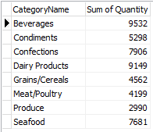
“Columns” layout will generate the output with a different column for each “Product Category”:
ByCategory.Layout := TGroupByLayout.Columns;

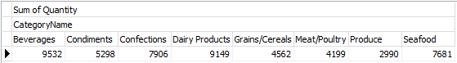
“Automatic” means TSummary will choose itself the “best” combination of “rows” and “columns” for each groupby, for example (using Year and Quarter groups) :
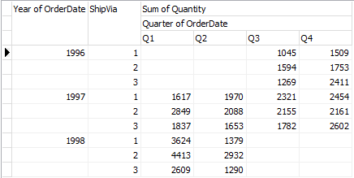

Expressions can also be used to “groupby”, for example:
S.AddGroupBy(TDataExpression.FromString(Customers,'Length(CompanyName)'));

Date time groups:
When using date-time data for grouping, we can specify which part of the date-time we need:
S.AddGroupBy( Orders[‘OrderDate’] ).DateOptions.Part := TDateTimePart.Month;
Any groupby can be duplicated in the same summary, so we can for example display results grouped by “Month” and by “Year”:
S.AddGroupBy( Orders[‘OrderDate’] ).DateOptions.Part := TDateTimePart.Year;

Numeric groups:
When using “continous” data such as float or integer values, TSummary can be configured to group results using an “histogram”:
var ByPrice: TGroupBy;
ByPrice:= S.AddGroupBy( Products[‘Price’] );
// For example we want to split the full “Price” range in 10 groups:
ByPrice.Histogram.NumBins:= 10;
// Or we can define the fixed size for each group:
ByPrice.Histogram.BinSize:= 200;
Other properties of Histogram enable defining the minimum and maximum values for the groups, which are calculated automatically by default.
Histogram groupby on “UnitPrice”:
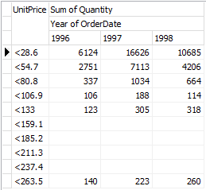

Filtering data in Summaries:

The TSummary class includes two different data filters:
One is using the Filter property, which is an expression used identically as in TBIDataset or TDataCursor: before calculating the summary aggregations, the Filter expression is evaluated, row by row, and only considers rows that pass the filter.
For example, in the above code that aggregates Orders quantities, we can select only the Order rows that belong to a Customer’s Country:
S.Filter:= TDataExpression.FromString(Customers, 'Country = “Mexico” ');
The other one is the Having property, equivalent to the SQL language clause with the same name. This is also an expression like Filter, but its used to select aggregations after the summary has finished calculating everything.
The difference is the Having property allows using summary measure names because they are completely calculated.
Example, using the above Summary code, only sums bigger than 5000 will be returned:
S.AddMeasure( Orders[‘Quantity’], TAggregate.Sum );
S.Having.Add('{Sum of Quantity} > 5000');
S.AddGroupBy( Categories[‘CategoryName’] );
BIGrid1.Data:= S.Calculate;

Note: A summary can also be used at design-time in high-level mode, clicking the “Data” property of a TBIDataSet, TBIGrid or TBIChart in the Object Inspector.
A design-time editor dialog provides a user interface to define the summary properties and preview the output.

TDataCursor
Any TDataItem can be sorted and filtered without altering its data arrays. TDataCursor creates a “view” of a data table or column. A “view” is essentially an index (an array of row integer positions).
TBIDataSet component includes a TDataCursor property to perform these operations, which in turn are used in TBIGrid and TBIChart.
A TDataCursor can also be used when exporting data (to JSON, XML, CSV, Excel, TDataSet, HTML, etc).
The TDataCursor “Loop” method sorts and filters data and traverses the resulting view, calling a user-defined procedure:
uses BI.DataSource, BI.Arrays;
var MyCursor : TDataCursor;
MyCursor:= TDataCursor.Create;
MyCursor.Data:= Orders;
.... we can set here the SortBy, Filter, etc properties...
MyCursor.Loop( procedure( const AIndex: TInteger)
begin
WriteLn( Orders[‘ProductID’].DataToString( AIndex ) );
end);

This is equivalent to calculating the cursor “Index” and doing a “for” loop on the index:
var t : Integer;
MyCursor.PrepareIndex;
for t:=0 to High(MyCursor.Index) do
WriteLn( Orders[‘ProductID’].DataToString( MyCursor.Index[t] ) );

Encryption
Sensible configuration data in TeeBI like passwords can be optionally encrypted using a small class and a “plugin” encryption engine.
To setup an engine you need to specify your desired “secret key” (an string) and a class that provides encryption and decryption.
There is currently one plugin available using “Turbopower’s LockBox”, available free from IDE Tools-> GetIt package manager, or at:
https://github.com/TurboPack
The code to use LockBox:
uses BI.UI, BI.Crypt.LockBox;
TBILockBox.Cipher:= TBICipher.Blowfish;
TBILockBox.SetKey('this is the secret key');
TCrypto.Engine:= TBILockBox;
Data that is currently encrypted are strings in the *.def files inside a store folder (see TDataDefinition class), for passwords used to connect to a database server and passwords for optional connections to a BIWeb server using an http proxy.
For custom encryption, the TCrypto class provides methods to encrypt/decrypt a String or a TStream.
var Encrypted, Decrypted : String;
Encrypted:= TCrypto.Encrypt(‘Hello’);
Decrypted:= TCrypto.Decrypt(Encrypted);

High Level
The low-level classes and features explained above, are used in “high-level” mode by several design-time components, user interface dialogs, and the “BIWeb” server.
This allows non-code working with all TeeBI features, inside the ide at design-time, or at runtime in your own applications, or using the BIWeb server configuration dialogs.
Important concepts:
Stores
A “Store” represents a location, a place, where you have data that has been already persisted to disk files using the BI.Persist unit classes.
Data can be saved to disk as in the first example of this document (creating the data by hand and then saving it to a disk file), or it can also be imported automatically from several sources and formats, and saved to disk.
To enable all user interfaces and design-time components to locate data (in high-level mode), its necessary to previously configure a machine with at least a defined “Store”.
Under Windows, this is simply a registry entry that is automatically generated using the “Store Manager” editor dialog:
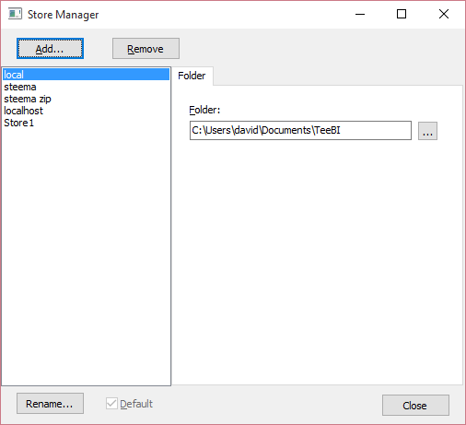

Here we have several stores, with the “local” store selected as “Default”.
A “store” can point to a disk folder in the same machine or network, or it can point to a www web address.
When using a web address, the Store expects a BIWeb server running at that site.
A store can also be defined to point to a web “localhost” server (a BIWeb running on the same machine).
Stores information are saved to Windows registry key:
HKEY_CURRENT_USER\SOFTWARE\Steema Software\TeeBI\Store
Or to a simple *.ini file for other systems (Mac OSX, iOS, Android).

The BI.Persist unit includes classes to manage stores by code (TStore and TStores classes). The TStore class can also be used to obtain (load) data from a Store into memory:
var D : TDataItem;
D:= TStore.Load( ‘SQLite_demo’ ); // <-- from the “default” store
or:
D:= TStore.Load( ‘Hong Kong’, ‘SQLite_demo’ ); // <-- from a specific “Hong Kong” store

When using a TStore to load data, it will automatically try first to locate the data in the global memory cache.
If it’s not there yet, it will appropriately load it from a disk file or from a web http server, transparently.
Data loaded via TStore does not need to be released explicitly (D.Free or D.DisposeOf), as it will be destroyed when the application finishes or the memory cache needs more memory.

TBIDataSet
A BIDataSet is like a normal TDataSet component, with a “Data” property that can be assigned at design-time or runtime:
BIDataSet1.Data := Orders;
BIDataSet1.Open;
When setting Data at design-time, the “origin” Store of the data (a disk file or web server address) will be persisted together with the dataset into the *.dfm or *.fmx form, for later reload.
BIDataSet has also a public “Cursor” property of type TDataCursor, enabling sorting and filtering, and a “Summary” property of type TSummary to provide query capabilities.
When linking a BIDataSet to a BIGrid or BIChart (through a standard TDataSource component), the grid and chart will detect and make use of the BIDataSet cursor features, for example to sort grid columns clicking them at the headers.

Importing data
Each “store” has a list of available “data” that has been imported or saved into it.
Data can be imported from different sources (files, databases, etc) into a common format (TDataItem class), and optionally persisted to local disk files in binary format for fast saving and loading.
Each data consists of the following files:
mydata.def
The *.def file is optional. It is only used for manually importing data using the Data Manager editor.
A *.def file is just an *.ini text file with the appropiate settings that define where is the source of the data to import and importing parameters, like a server connection name when importing a database.
These settings are manually edited using the Data Manager.
Programatically, *.def files can be created and modified using the TDataDefinition class
mydata.bi
A *.bi file is a binary file containing the information of the data structure. This is the number of “columns”, type of each column and other parameters.
The TPersistence class (in BI.Persist.pas unit) allows reading and writing *.bi files at low-level.
mydata.databi
A *.databi file is a binary file containing the “real” data arrays, one array for each column, and optional arrays for the column “missing” (null) values and the “map” (index) of the column array.
The TDataPersistence class (in BI.Persist.pas unit) allows reading and writing *.databi files at low-level.

The “Data Manager” editor dialog, usable at design-time and runtime, allows adding/removing data items and configuring them to import and persist the data.
Importing data can also be done at runtime without the Data Manager editor, for example:
uses BI.Data.XML;
var X : TBIXML;
X:=TBIXML.Create;
var Books : TDataItem;
Books:= X.Import(‘books.xml’);

A simplified version of the above code automatically detects the file extension to avoid needing to create a TBIXML variable:
uses BI.DataSource, BI.Data.XML;
Books:= TBIFileSource.ImportFile(‘books.xml’);
The same applies to files with *.json, *.csv, *.xls, *.cds etc extensions. Just using the appropiate BI.Data.xxx unit, enables the automatic extension discovery.
Other helper methods in TBIFileSource and importing classes:
- TBIFileSource.ImportURL( ‘http://acme.com/mydata.json’);
- X.Import( Memo1.Lines ); // any TStrings containing xml data
- TBIFileSource.Import(‘c:\myfolder’, ‘*.*’, ‘’, True) // recursive folder import
- TBIDB.Import( FDConnection1 ); // database connections
- TBIDatasetSource.Import( MyDataSet1 ); // any TDataset-derived

Data Manager dialog (and all other dialogs) are available for both VCL and Firemonkey frameworks:
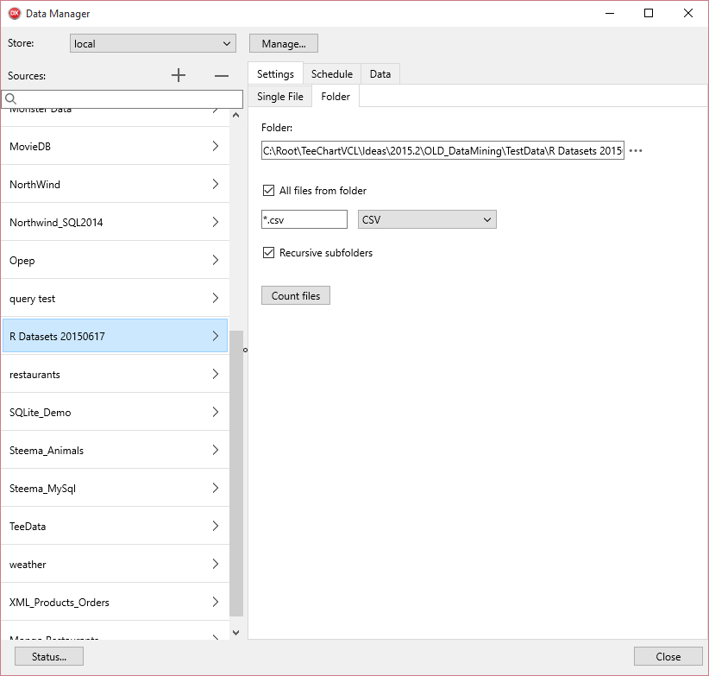

Different sources can be configured in the Data Manager, like:
- Text files (CSV, JSON, XML) from a folder or an URL.
- Microsoft Excel spreadsheets
- Database connections (using FireDAC, SQLExpress or other libraries)
- Data that is in another BIWeb server
- Contents from compressed *.zip files

Notes about the different data formats and importing them:
The units and classes related to importing data (BI.Data.xxx) can be used also by code, with more methods and flexibility (like for example importing contents of a TMemo.Lines or TStrings, or importing a live TDataSet instance of any class).

XML, JSON and databases can be imported using a default “engine” or specifying a custom one.
The above example uses the “default” engine (just using the parameterless Create constructor).

For XML, the available engines are:
- XmlDom (the standard xml code included by default in Delphi)
- Omni ( https://code.google.com/p/omnixml )

To specify an “engine”, the only change is the import class should be created like:
uses BI.Data.XML.Omni;
X:=TBIXML.CreateEngine(TOmniXML.Create);
Similar to xml, JSON import supports:
- System.JSON (or DBXJSON for older Delphi versions)
- SuperObject ( https://github.com/hgourvest/superobject )

and the same code to use any of them, for example:
uses BI.Data.JSON.SuperObject;
X:=TBIJSON.CreateEngine(TSuperObject.Create);
Importing databases can also be done specifying a different engine.
The available options are:
- FireDAC (or SqlExpress)
- BDE
- UniDAC
uses BI.Data.DB.SqlExpr;
X:=TBIDB.CreateEngine(TDBSqlExprEngine.Create); // <-- use SqlExpress instead of FireDAC
Other “engines” will be implemented in the near future.

Exporting data
In the same units that contain the import classes (BI.Data.xxx), there are exporting classes to perform the opposite, for example to generate a JSON file from the “Orders” TDataItem:
uses BI.Data.JSON;
var JSON : TBIJSONExport;
JSON:= TBIJSON.ExportFormat;
JSON.Data := Orders;
WriteLn( JSON.AsString );

Data can be exported to the following formats: CSV, HTML, XML, JSON, Excel, ClientDataset, PDF.

Microsoft Excel exporting:
Any TDataItem object can be exported to Microsoft Excel format (*.xls, *.xlsx, etc), without the need to have Excel installed on that machine, by using a “plugin” class to a 3rd party library.
The unit BI.Data.Excel.TMSFlexCel implements a small “plugin” to use TMS FlexCel library, available at:
https://www.tmssoftware.com/site/flexcel.asp
Other plugin classes should be easy to create as the quantity of code is minimal.
Example code:
uses BI.Data.Excel, BI.Data.Excel.TMSFlexCel;
TBIExcelExport.Engine:=TBITMSFlexCel;
TBIExcelExport.SaveToFile(MyData, ‘mydata.xlsx’);

Beta note: PDF exporting is not yet finished.

Statistics and Maps
Several basic statistic formulas are calculated when importing data.
TDataItem has a “Stats” property that returns the calculations at column and table level.
These basic values (things like Standard Deviation, Kurtosis, Skewness, etc, etc) are intended to be used by the machine-learning algorithms. Calculating them in advance, at import time, and persisting them together with the data saves time.
A “map” of each column is also created. A map is a class that contains a sorted array with the unique element values of a data item, and the frequency of each element (the number of times it appears).
The map sorted array is used for fast searching of data (using a binary search algorithm).

BIWeb Server
BIWeb is a simple project to generate an executable (VCL and Firemonkey) that implements a simple http server using Indy THttp component. Full sources are included.
The server runs as a taskbar tool icon and allows remote clients to request data, calculate and return summaries, and to return exported data in html (<table>), jpeg, png, json, xml, etc formats.
When using the TStore.Load method from a client application pointing to a remote “store”, the store automatically configures the url and initiates the request to a BIWeb.
BIWeb then responds with a binary stream that is a mirror 100% of the stream persisted in the remote disk.
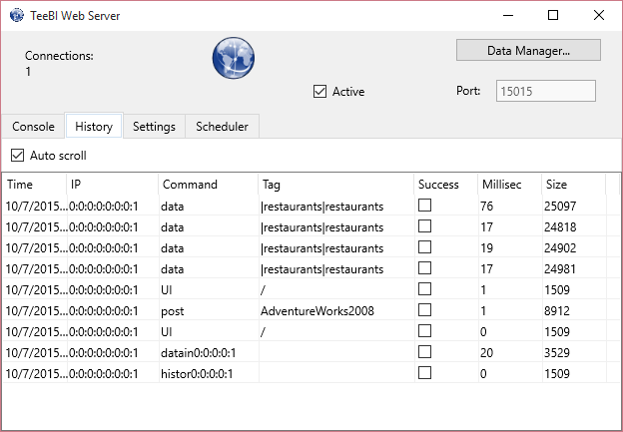

The default ip port for BIWeb is 15015.
Clients can request data using zip compression, by code or configuring it at TStore editor dialog.
BIWeb can also be called and managed from a normal browser (Chrome, Firefox, etc), for example:
http://steema.cat:15015/?data=SQLite_demo|Products&format=.htm
http://steema.cat:15015/?data=SQLite_demo|Products&format=.htm&sort=UnitsInStock:descending
http://steema.cat:15015/?data=SQLite_demo|%22Order%20Details%22&format=.htm&summary=sum(Quantity);Categories.CategoryName

Requesting data from a BIWeb server by code, example:
if TStores.IndexOf('London’)=-1 then
TStores.Add('London’,'web:www.acme.co.uk:15015');
var Products : TDataItem;
Products:=TStore.Load('London','SQLite_Demo')['Products'];

Queries (TDataSelect class) and summaries (TDataSumary class) can be executed remotely in a BIWeb server and the query output results returned as a TDataItem object by requesting a URL with the query parameters.

GEO (geographical) metadata
The BIChart control (when using the “Pro” version of TeeChart) is capable of displaying world maps, but it firsts needs to know the geographical level (continents, countries, states, cities, counties...) of the data to plot, and the relationship link between your custom data and the internal TeeChart geo entities.
This can be accomplished by using an internal “Geo” TDataItem, for example:
// Link our country name to Geo country name:
MyData[‘Country’].Master:= Geo[‘Countries’][‘Name’];

Machine Learning Algorithms
Included in TeeBI are two native algorithms developed in Delphi language, with more to come:
- DecisionTree (unit BI.Algorithm.DecisionTree)
- Clustering (unit BI.Algorithm.Clustering)
Example of use by code:
uses BI.Algorithm.DecisionTree;
var Tree: TDecisionTree;
Tree:= TDecisionTree.Create( Orders );
Tree.Target:= Orders[‘Price’];
Tree.Attributes:= [ Orders[‘Quantity’], Orders[‘OrderDate’] ];
Tree.Calculate;
In this case of a TDecisionTree, the algorithm output is a tree of nodes that can be iterated and used in different ways, like displaying it:
Memo1.Lines:= GetTreeRules( Tree.Root );

R integration:
R is a free language ecosystem for statistical computing and machine-learning.
https://www.r-project.org
With “R” language integrated with TeeBI, it is possible to invoke any “R” script or algorithm, calling it passing TDataItem data and obtaining the results into other TDataItem objects.
The BI.Plugins.R.pas unit contains the current implementation of the class to interact with R.

Python / Scikit-learn integration:
Similar to above R integration, the BI.Plugins.Python.pas unit contains classes to interact with Python.
The integration is done using an adapted subset of the excellent Python4Delphi project:
https://github.com/pyscripter/python4delphi

Several popular algorithms from Scikit-learn / numpy are included, with more to come.
Both R and Python algorithm classes derive from a common TModel class (in BI.Algorithm.Model.pas unit) that includes methods to split source data into train/test subsets, evaluate a “Confusion Matrix”, return the Predicted values as a TDataItem, etc.

Visualizing data

Grids
Any TDataItem (and its children items, sub-items and master-detail related data items) can be visualized using a “grid” control.
The BI.VCL.Grid and BI.FMX.Grid units implement a container control for a “real” grid.
The default Grid control used to display data is the VCL TDBGrid and the Firemonkey TGrid.
Other grid controls can be easily selected, currently being:
- JVCL Grid ( http://jvcl.delphi-jedi.org )
- SMDBGrid (VCL http://www.scalabium.com/smdbgrid.htm )
- TMS Grid for Firemonkey (http://www.tmssoftware.com )
- Woll2Woll FirePower grid (http://www.woll2woll.com )

The TBIGrid container control is configured by default to enable sorting and filtering by mouse-clicking the grid column headers, using the standard VCL and FMX grid controls included in Delphi.
Other grids might support more advanced features, accessible via this property:
var JGrid : TJVDBGrid;
JGrid := BIGrid1.Plugin.GetControl as TJVDBGrid;
Selecting a grid is done by setting the Plugin property, for example:
BIGrid1.Plugin := TBIJVCLGridPlugin.Create(BIGrid1);

A TDataItem can be displayed onto a BIGrid at runtime in different ways:
- by setting the Data property: BIGrid1.Data := MyDataItem;
- by setting the DataSource property linked to a BIDataset:
BIDataset1.Data:= MiDataItem;
DataSource1.DataSet:= BIDataset1;
BIGrid1.DataSource:=DataSource1;
- Calling the BIGrid BindTo method:
BIGrid1.BindTo(MyDataItem);
At design-time, the BIGrid Data property can be changed in the Object Inspector, using the Data Manager dialog to select the desired store (local or remote), and the data item to visualize.

Grid Colorizer
A feature of TBIGrid (beta note: VCL only) allows defining a formula to fill the grid cells interior with a color calculated using all cells of a given range.
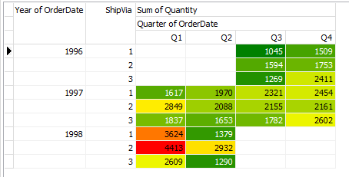

Several properties allow customizing the number of colors, changing the text font color for better readibility or inverting the formula.
uses BI.UI;
var MyColors : TDataColorizer;
MyColors.Data:= SumOfQuantity; // <-- The selected TDataItem
BIGrid1.Colorize([ MyColors ]); // <-- array with one or more items
// optional properties:
MyColors. TextColor:= TColorizeTextColor.Automatic;
MyColors.Inverted:= False;
MyColors.Colors.Clear;
MyColors.Colors.Add(0,TAlphaColors.White);
MyColors.Colors.Add(1,TAlphaColors.Darkblue);

For each “colorizer”, the minimum and maximum values of the Data item will be calculated and then each cell value determines the interpolated color used to fill the cell.

Charts
Similar to grids above, any TDataItem can be visualized in graphical format using the TeeChart control.
When using the TeeBIRecompile.exe tool to recompile TeeBI source code, each ide is inspected to detect which version of TeeChart is currently installed, and the BIChartxxx packages are configured to use either TeeChart “Pro” or TeeChart “Lite” versions.
The “Pro” version enables more functionality, like automatic custom axes to display complex TDataItem sub-data, axes scrollers, many more charting styles (series types) and so on.

Technical notes:

Supported IDEs:
Due to heavy internal usage of record helper classes and other modern-Delphi language features, the minimum supported IDE is Idera/Embarcadero RAD Studio XE4 and FreePascal FPC v3.0.

It might be possible to port TeeBI code to older IDE levels if there is enough developer demand.

Packages:
Note:
An automated tool (TeeBIRecompile.exe) automatically detects, compiles and installs all the packages for all the supported IDEs.
Depending on the IDE version (XE4, XE5, etc), TeeBIRecompile modifies the dpk packages before recompiling them, enabling or disabling other required packages that might exist or not in that particular ide and for a particular platform (Windows, iOS, Mac OSX, Android, etc).
The automatic recompilation copies the prepared dpk package sources into a “Sources\Temp” folder, and then recompiles them.

Original packages are located at this folder:
..\TeeBee\Sources\Packages
The core TeeBI units are included by default in a TeeBI.dpk package.
These units compile in all possible platforms (Windows, Mac OSX, Android and iOS).
TeeBI package is required by all the other packages.
VCLTeeBI and DCLTeeBI packages include all units that use the VCL component library.
They register the TBIDataSet component, and the TBIGrid and TBIChart VCL controls.
Identically, FMXTeeBI and DCLFMXTeeBI packages include all units that use the Firemonkey FMX component library.
They register the TBIGrid and TBIChart Firemonkey controls.
A special package, FireDACTeeBI, contains all FireDAC-related units.
A similar package, SQLExprTeeBI, contains all SQLExpress units.
The TeeBIAlgorithms package includes all units BI.Algorithm.* with the machine-learning and statistical classes.

TeeChart Lite or Pro:
The TBIChart control (VCL and Firemonkey) can be compiled in two different modes, depending on which TeeChart version is installed for a particular IDE.
Package names are: VCLChartTeeBI, VCLChartProTeeBI, FMXChartTeeBI and FMXChartProTeeBI.
The “Lite” TeeChart version is much less capable of visualizing data than the “Pro” version.
uses BI.FMX.Chart;
BIChart1.BindTo( MyData );

Memory limits:
A TMemory class provides several class functions:
TMemory.Allocated: returns the number of bytes used by the application
TMemory.Available: returns the number of bytes still free in the operating system.
TMemory.TotalPhysical: returns the total number of bytes of installed memory in the system.
A global class variable can be configured to specify the mininum number of bytes that should be available at all times.
For example, we might reserve a 20% of memory:
TMemory.MinLimit := (20 * TMemory.Available) div 100;

Beta note:
TeeBI memory management currently is not automatically releasing “old” or “few used” data until the data item object is freed.
The future goal is to enable this automatic mechanism to minimize the potential problem of using all the available memory in the system, as TeeBI already maintains a list of all data that is loaded into memory, and the “last access time” for each item.
The manual solution is to destroy the TDataItem objects (MyData.Free or DisposeOf), or to call MyData.UnloadData to release the internal array, which will be automatically re-loaded from disk or web into memory as soon its required.

List of 3rd party products that can be used with TeeBI:

TMS FlexCel | https://www.tmssoftware.com/site/flexcel.asp | Copyright © 1995 - 2016 TMS Software v4.0
TurboPack LockBox | https://github.com/TurboPack | Copyright © 1997 – 2002  by TurboPower Software Co.
Omni XML | https://code.google.com/p/omnixml | Copyright © 2002-2012 by Miha Remec and Primož Gabrijelčič
SuperObject JSON | https://github.com/hgourvest/superobject | Henri Gourvest <hgourvest@gmail.com>
UniDAC | https://www.devart.com/unidac/ | Copyright © 1998 - 2016 Devart.
TMS Grid Pack FMX | https://www.tmssoftware.com/site/gridpack.asp | Copyright © 1995 – 2016 TMS Software v4.0
Woll2Woll FirePower | http://www.woll2woll.com/ | Copyright © Woll2Woll Software
SMDB Grid | http://www.scalabium.com/smdbgrid.htm | Copyright© 1998-2016, Scalabium Software
JVCL | http://jvcl.delphi-jedi.org/ | Copyright (c) 2004 by the JVCL Team
microOLAP MySQL | https://www.microolap.com/ | Copyright © 2000—2016 MicroOLAP Technologies LTD

Statistical and machine-learning libraries:

R language | https://www.r-project.org/ | © The R Foundation.
Python, Scikit-learn | http://www.scikit-learn.org | © 2010 - 2016, scikit-learn developers
Python4Delphi | https://github.com/pyscripter/python4delphi | Dr. Dietmar Budelsky  dbudelsky@web.de  Morgan Martinet  e-mail: p4d@mmm-experts.com

